**LAB # 01**

**Task 1: Create class diagram with 5 classes and apply forward engineering approaches to generate code.**

**Solution :**

private class Librarian extends LibraryManagementSystem {

public Librarian(){ }}

private class Database extends LibraryManagementSystem {

public Database(){}}

private class Student extends LibraryManagementSystem {

public Student(){}}

private class Books extends LibraryManagementSystem {

public Books(){ }}

private class LibraryManagementSystem {

public LibraryManagementSystem(){ }

**OUTPUT :**

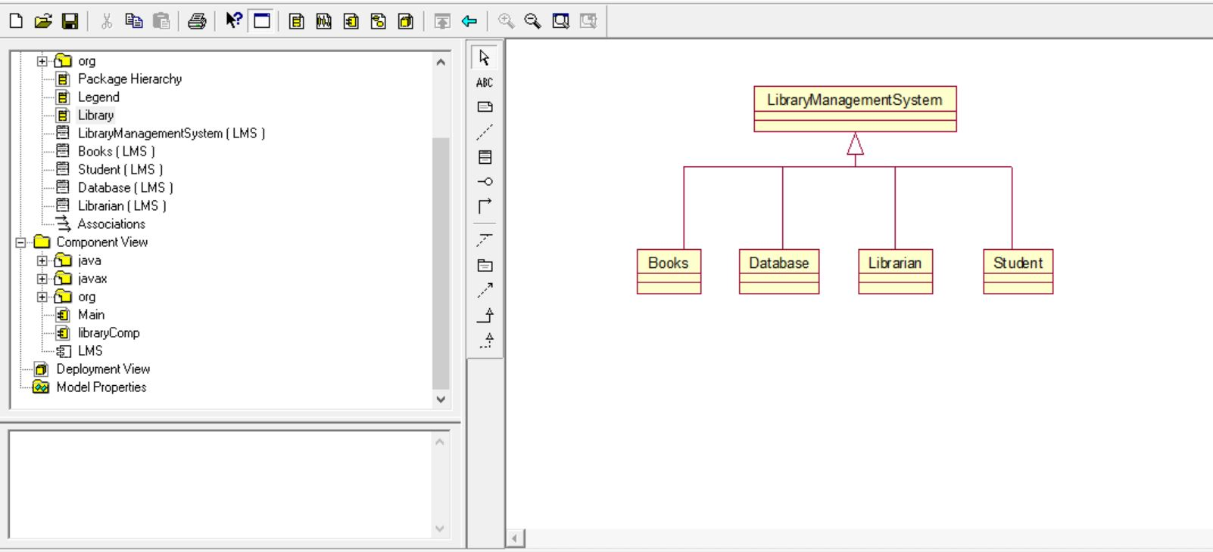

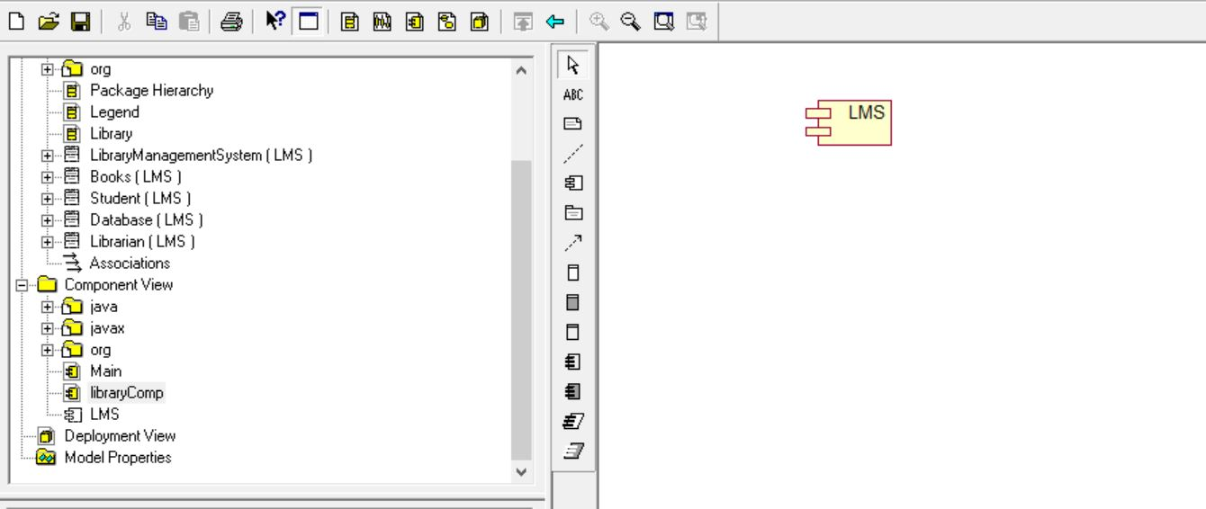

**Task 2: From forward engineering update your Generated java code and add attributes and operations in your classes.**

**Solution :**

private class Librarian extends LibraryManagementSystem

{ public String Name;

public int ID;

private int Password;

public void Verify_Librarian(){ }}

private class Database extends LibraryManagementSystem {

public String Book;

public void Add(){ }

public void Delete(){ }

public void update(){ }

public void Search(){ }}

private class Student extends LibraryManagementSystem {

public int ID;

public int Name;

public int amount;

public void Check_Account(){ }

public void get_Book(){ }

private void Calc_Fine(){ } }

private class Books extends LibraryManagementSystem {

public String Title;

public String Author;

private int ISBN;

public void Reservation_status(){ }

public void Feedback(){ }

public void Book_Request(){ }}

private class LibraryManagementSystem {

public String UserName;

public String Password;

public void Login(){ }

public void Register(){ }}

**Task 3 : Reverse Engineer your edited code in task2 and display updated UML diagram.**

**Solution :**

